To: Kay Schröder, Daily Interactive

From: William Lamb, Mercator Research Institute for Global Commons and Climate Change (MCC), Torgauer Str. 12-15, 10829 Berlin, Germany

**Re. Service description for three SRM graphics**

Dear Kay,

We would like to contract your services to produce three graphics in a similar size, style and color format as shown below (Figure 1). A description of the three graphics with examples are given below (Figs 2-4), and further information can be provided by email or phone.

We require an initial version of each graphic – to which we will respond with feedback and potential adjustments – and a final version in vector format.

Please indicate to us in writing the cost for this service.

Thanks & best regards,

William Lamb

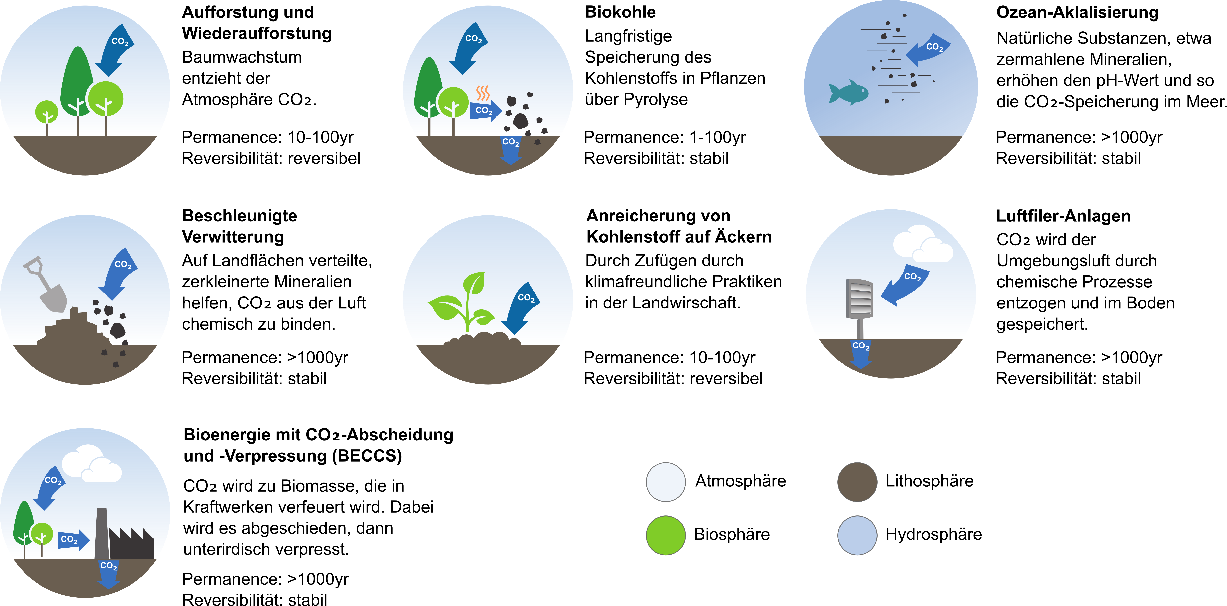

Figure 1: existing graphics

*Figure 2: Stratospheric Aerosol Injection* – Stratospheric aerosol injection aims to limit the effects of climate change by using planes or balloons to spray small particles of substances (aerosols) into the upper atmosphere. Sulfur dioxide is one example of a substance we could use. The particles would reflect sunlight back into space. This could cool temperatures on Earth. But for this idea to work, we would have to keep doing it continuously. If we stopped, temperatures would rise once again, and probably very quickly, Also, stratospheric aerosol injection would not do anything to reduce our greenhouse gas emissions or help with other impacts, such as ocean acidification.

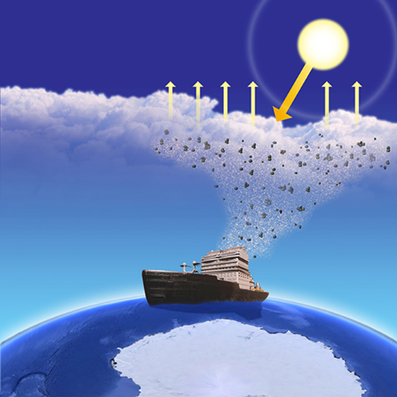*Figure 3: Marine Cloud Brightening* – Marine cloud brightening aims to limit the effects of climate change by spraying small particles of substances, such as sea salt, into the air over the oceans, to make clouds brighter. These clouds would reflect sunlight away from the Earth, which could cool temperatures on a local or regional level. Marine cloud brightening might also help to protect ecosystems threatened by climate change. One way to spray the particles would be to use a fleet of ships. But for this idea to work, we would have to keep doing it continuously. If we stopped, temperatures would rise once again, and probably very quickly. Also, marine cloud brightening would not do anything to reduce our greenhouse gas emissions or help with other impacts, such as ocean acidification.

*Figure 4: Space-based Geoengineering* – Space-based geoengineering aims to limit the effects of climate change by putting a giant mirror or other reflective material in outer space between the Earth and the sun. Such a space mirror or sunshield would deflect sunlight back into space. This could cool temperatures on Earth. Space-based geoengineering also would avoid direct changes to the land, oceans, or atmosphere of the Earth itself. But for this idea to work, we would need to be able to build and maintain something in space much larger than ever before. A space mirror would also be very costly to build, given that its location would be about four times as far from the Earth as the Moon. Also, it would not do anything to reduce our greenhouse gas emissions or help with other impacts, such as ocean acidification.